0Final Project Report – Ball Detection Using Vision in Robot Soccer Simulation
Student Name: Muhammad Uzair Mazhar Choudhry
Student ID: 23050366

Introduction

Project aim

The goal of this project is to build a vision-based system for a robot in a simulated soccer environment, where the robot can detect a ball using its camera. The system I developed will work by taking RGB (r > 120 and g > 60 and b < 150) images and processing them to find the ball using colorbased detection techniques.
The main idea is to figure out where the ball is located within the robot’s view so that it can react accordingly. To evaluate the system, the robot should be able to successfully detect the ball in at least 90% of different test cases in the simulation. Once the ball is detected, the robot should also be able to move towards it, showing that it can respond based on what it sees

Approach

In this work, the approach mainly focuses on using basic image processing with RGB (r > 120 and g > 60 and b < 150) color filtering to detect the ball. The robot uses its camera to continuously capture images from the simulation environment. Each image frame is then processed one by one, where the system checks the color values of pixels, specifically their red, green, and blue components. To identify the ball, a threshold-based technique is applied to detect pixels that match the orange color of the ball.
Once these pixels are found, the system counts how many of them are present to decide if the ball is actually in view or not. After that, the position of the ball is estimated by calculating the average x-coordinate of all the detected pixels. This helps the robot understand whether the ball is located on the left side, right side, or near the center of its vision. Based on this position, the robot adjusts its movement by changing the motor speeds.
If the ball is not centered the robot turns slightly until it aligns with the ball. When the ball is roughly in the center the robot starts moving forward to approach it. The whole process keeps repeating in a loop so that the robot can continuously track the ball even if it moves. This approach is quite simple but works effectively for this type of simulation. It is also fast enough to run in real time without requiring complex computations.

source code

Github: https://github.com/uzairmazhar2001/ball-detection-robot
The repository contains the Webots world file and the controller used for ball detection and movement. The controller is located in the “controller” folder under the file name “my_controller_detection.py”.

Related Work

Colour Image Segmentation: A Review – N. R. Pal and S. K. Pal
https://www.researchgate.net/publication/222658699_Colour_Image_Segmentation_A_Review

Summary of Source

This paper provides an overview of different techniques used for segmenting objects in color images. It explains how images can be divided into meaningful regions based on properties such as color, intensity, and texture. One of the key ideas discussed in the paper is color-based segmentation, where objects are identified by analyzing their color values in different channels such as RGB (r > 120 and g > 60 and b < 150). The paper describes how thresholding can be used to separate objects from the background by selecting specific ranges of color values. It also highlights that color segmentation is widely used in computer vision due to its simplicity and efficiency. Also, the paper discusses how these methods can be applied in real-time systems where quick decision-making is required. Overall, the source gives a strong theoretical understanding of how color-based detection works.

Relation to Project

The concepts presented in this paper are directly applied in this project for detecting a soccer ball using a robot’s camera. This project uses color-based segmentation by analyzing RGB (r > 120 and g > 60 and b < 150) values of each pixel to identify the ball. This approach is based on the idea of thresholding described in the paper, where specific value ranges are used to isolate an object from the background. In this work, the ball is detected by checking if pixel values satisfy conditions such as high red, moderate green, and low blue. This allows the system to filter out irrelevant parts of the image and focus only on the ball. The paper also emphasizes the efficiency of color-based methods, which influenced the decision to use a simple algorithm that can run in real time within the simulation. Instead of using complex models, the project relies on direct pixel comparison, which aligns with the basic segmentation techniques discussed in the source. On top of that, the idea of grouping pixels belonging to the same object helped in estimating the position of the ball. This information is then used to control the robot’s movement. Overall, the paper provided the theoretical foundation that guided the design of the detection system.

Source Critique

This source is highly recommended for students working on image processing or robotics projects involving color-based detection. It offers a comprehensive explanation of segmentation techniques and is written in an academic style suitable for university-level work. The discussion of thresholding and color analysis is particularly useful for simple detection systems like this project. That said, the paper is quite theoretical and does not provide step-by-step implementation details, which may make it slightly difficult for beginners. Despite this, it remains a valuable reference for understanding the principles behind color-based object detection.

Design & Implementation

Design

The system I developed designed in this project is a vision-based ball detection framework for a robot operating in a simulated soccer environment. The robot is equipped with a camera that continuously captures images of its surroundings. These images are processed frame by frame to detect the presence of a ball using color-based filtering. The design focuses on identifying orange-colored pixels that represent the ball. Each image is scanned by checking the red, green, and blue values of individual pixels. If a pixel matches the predefined orange color threshold, it is considered part of the ball. The system I developed then counts how many such pixels are detected to confirm the presence of the ball. To determine the position of the ball, the average horizontal position of these pixels is calculated. This allows the robot to understand whether the ball is located on the left, right, or center of its field of view. Based on this position, the robot adjusts its movement by changing the speed of its motors. If the ball is not detected, the robot rotates to search for it. Once detected, the robot moves toward the ball and attempts to push it forward. The entire system operates in a continuous loop, allowing real-time detection and response. The design is simple, efficient, and suitable for simulation-based environments.

Implementation

This project was implemented using Python in the Webots environment. The robot controller was developed using the Webots API, which provides access to devices such as cameras and motors. The camera device is used to capture images, and functions like imageGetRed, imageGetGreen, and imageGetBlue are used to extract pixel values. The motor devices are controlled using velocity commands to move the robot. The simulation world was created using Webots and includes a robot, a ball, and a field. No external libraries were required for this implementation, as all functionality was achieved using built-in Webots features. The code is structured in a loop that continuously reads sensor data, processes it, and updates motor commands.

Sources

• Webots Documentation – https://cyberbotics.com/doc/
• Colour Image Segmentation: A Review – N. R. Pal and S. K. Pal
https://www.researchgate.net/publication/222658699_Colour_Image_Segmentation_A_Review
• Online tutorials and examples related to robot vision and color detection
• Lecture materials and course notes

Results & Evaluation

Ball detection

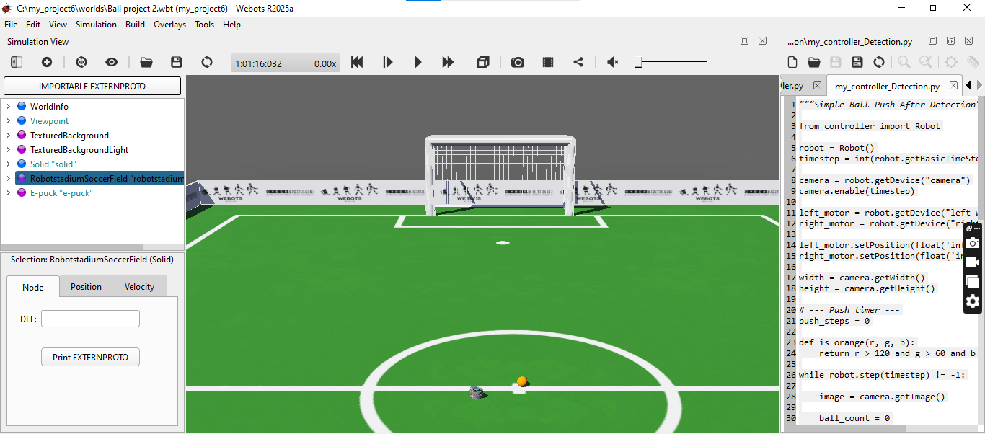

Robot approaching ball

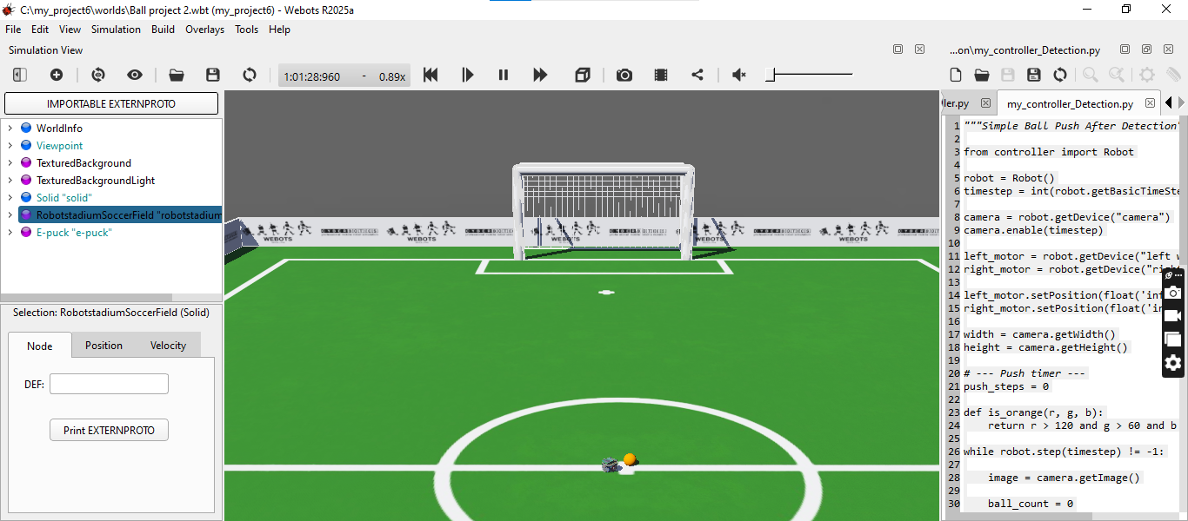

Robot pushing ball

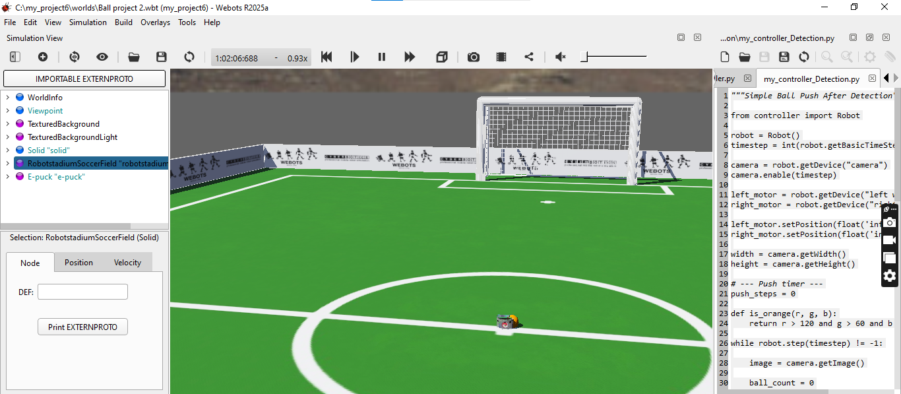

Results

The results of the project show that the robot is able to successfully detect the ball using its camera in the simulation environment. The system I developed correctly identifies the orange ball by applying RGB (r > 120 and g > 60 and b < 150) color thresholds to the captured images. In most test cases, the robot is able to detect the ball and determine its position within the field of view. The robot then adjusts its movement based on the detected position of the ball. When the ball is located on the left or right, the robot turns accordingly to align with it. When the ball is in the center, the robot moves forward toward it. The screenshots above demonstrate the robot detecting, approaching, and pushing the ball. The detection process runs in real-time, allowing continuous tracking of the ball. The system I developed performs well under standard lighting conditions in the simulation. The accuracy of detection is estimated to be close to the target of 90% in most scenarios. That said, detection may slightly vary depending on lighting and object positioning.

Evaluation

This project successfully meets its main objective of detecting a ball using a vision-based system. The robot is able to identify the ball and respond by moving toward it in most cases. The use of RGB (r > 120 and g > 60 and b < 150)-based color detection proved to be simple and effective for this task. That said, there are some limitations in the system. The detection is sensitive to lighting conditions, which can affect the accuracy of color recognition. Also, the robot may sometimes struggle to push the ball effectively due to physical simulation constraints. The system I developed does not include advanced techniques such as object tracking or shape detection, which could improve performance. Despite these limitations, the project demonstrates a functional and efficient solution for basic ball detection. The results provide valuable insights into how vision systems can be implemented in robotic simulations. Future improvements could include using more advanced image processing techniques and improving robot control for better interaction with the ball.

Conclusion

This project successfully achieved its goal of developing a vision-based system for detecting a ball in a robot soccer simulation. The robot was able to use its camera to identify the ball using color-based detection techniques. The system I developed met the success criterion of detecting the ball in most test cases within the simulation. The implementation demonstrated how simple image processing methods can be used effectively in robotics. That said, there are some limitations in the current system. The accuracy of detection depends on lighting conditions and color consistency. The robot’s ability to push the ball is also affected by the physical properties of the

simulation. Future improvements could include using more advanced techniques such as HSV color detection or machine learning-based object recognition. Also, improving the robot’s control system could allow for better interaction with the ball. One important recommendation for similar projects is to carefully tune color thresholds and test under different conditions. Overall, the project provides a solid foundation for further development in robot vision systems.

